### **Project 01**

#### **Project Overview**

Your organization is implementing continuous integration (CI) practices to streamline the software development lifecycle. As part of this initiative, you will create a Jenkins declarative pipeline for building a simple Maven project hosted on GitHub. This project aims to automate the build process, ensure code quality, and facilitate continuous delivery (CD).

#### **Objectives**

* Create a Jenkins pipeline script using declarative syntax.
* Clone a Maven project from a specified GitHub repository.
* Execute the build process and run unit tests.
* Archive build artifacts.
* Provide clear feedback on build status through Jenkins' UI and console output.

#### **Instructions**

1. **Setup Jenkins Job**
   * Create a new Jenkins pipeline job.

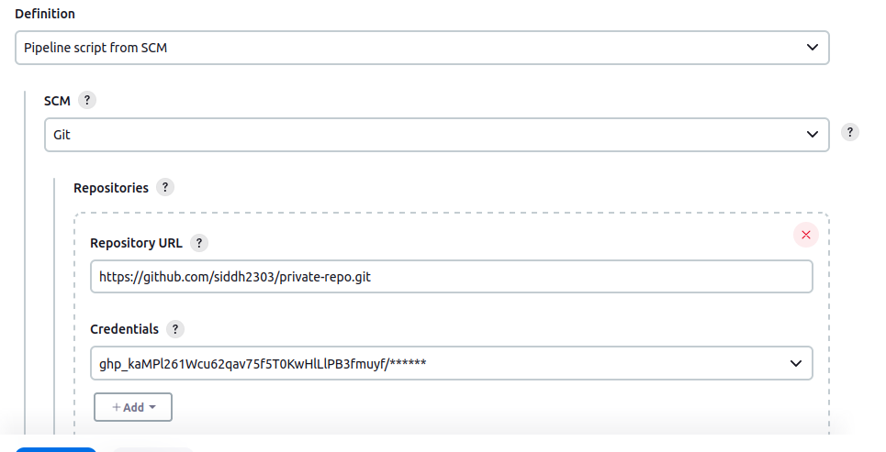

* + Configure the job to pull the Jenkinsfile from the GitHub repository.

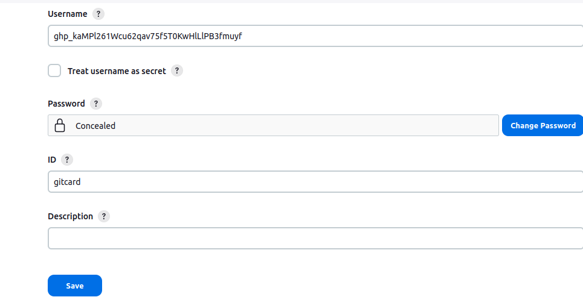

1. **Create Jenkinsfile**
   * Write a declarative pipeline script (Jenkinsfile) that includes the following stages:
     + **Clone Repository**: Clone the Maven project from the GitHub repository.
     + **Build**: Execute the Maven build process (mvn clean install).
     + **Test**: Run unit tests as part of the Maven build.
     + **Archive Artifacts**: Archive the build artifacts for future use.

Jenkins File:

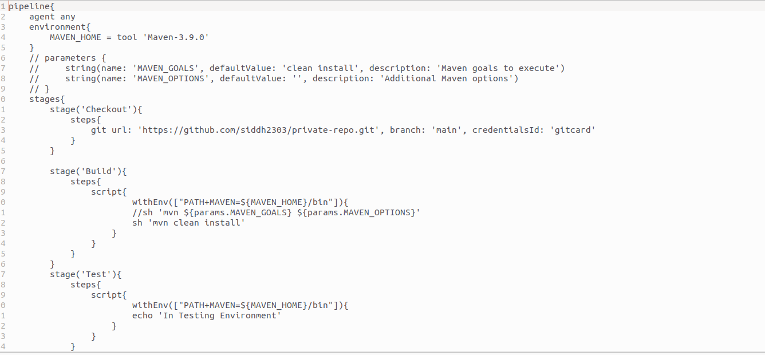

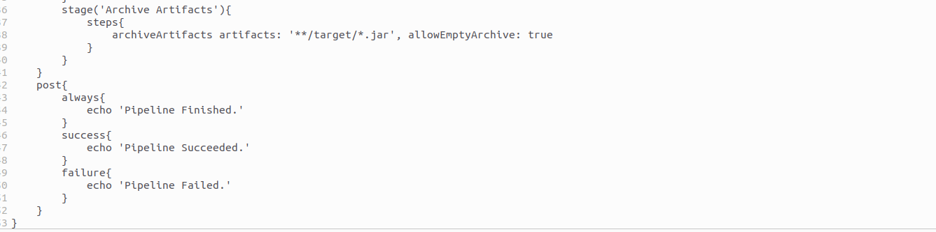

1. **Configure Pipeline Parameters**
   * Allow the pipeline to accept parameters such as Maven goals and options for flexibility.
   * Ensure the pipeline can be easily modified for different build configurations.

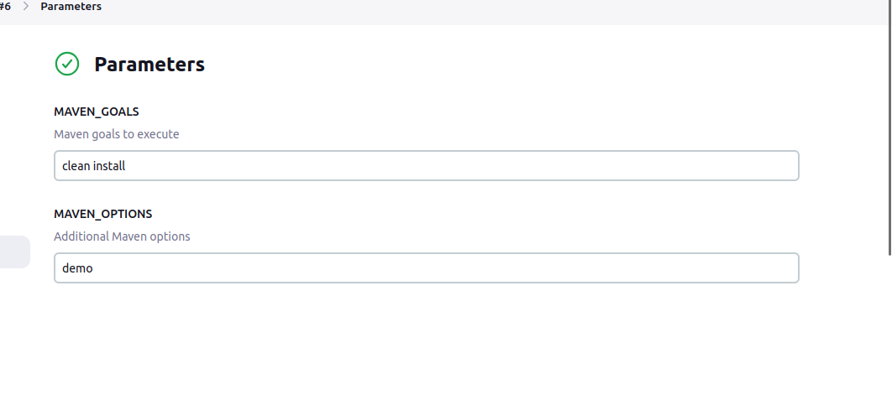

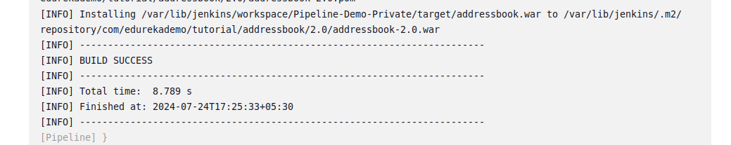

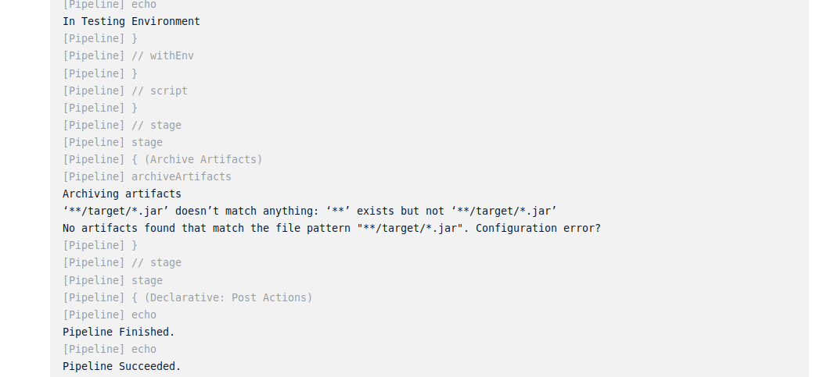

1. **Run the Pipeline**
   * Trigger the Jenkins pipeline job manually or set up a webhook for automatic triggering on GitHub repository changes.
   * Monitor the build process through Jenkins' UI and console output.

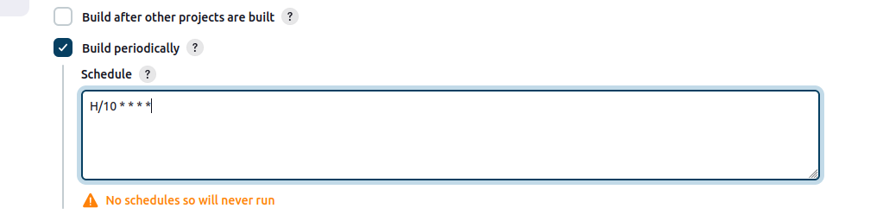

1. **Deliverables**
   * **Jenkinsfile**: A declarative pipeline script with the defined stages and steps.
   * **Jenkins Job Configuration**: Configured Jenkins job that uses the Jenkinsfile from the GitHub repository.
   * **Build Artifacts**: Successfully built and archived artifacts stored in Jenkins.
   * **Build Reports**: Output of the build process, including unit test results, displayed in Jenkins.
   * **Pipeline Visualization**: Visual representation of the pipeline stages and steps in Jenkins, showing the flow and status of each build stage.
   * **Documentation**: Detailed documentation outlining the pipeline setup process, including prerequisites, configuration steps, and instructions for modifying the pipeline.